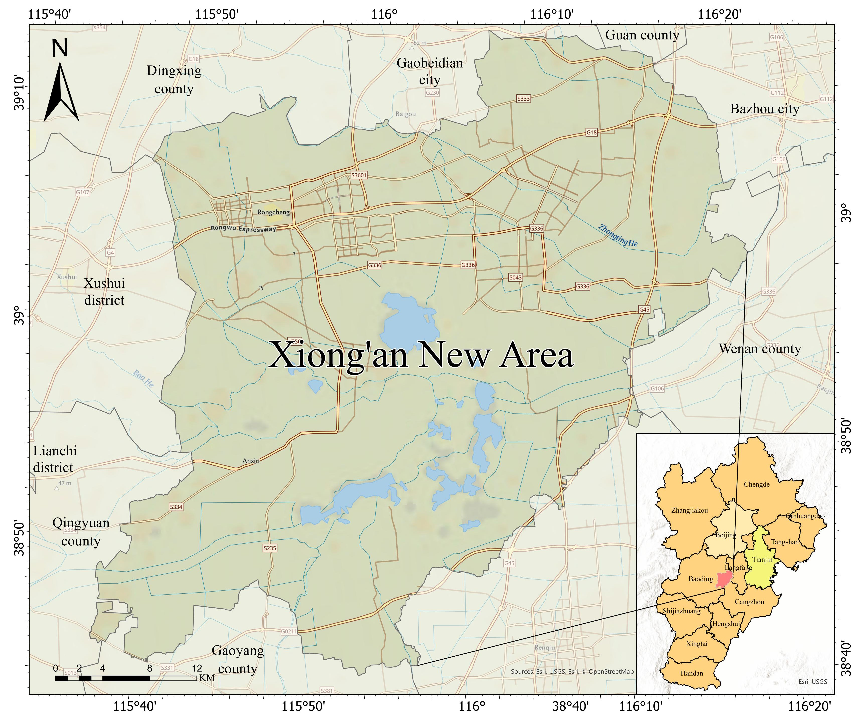

**Figure A1.** Study Area Location Map

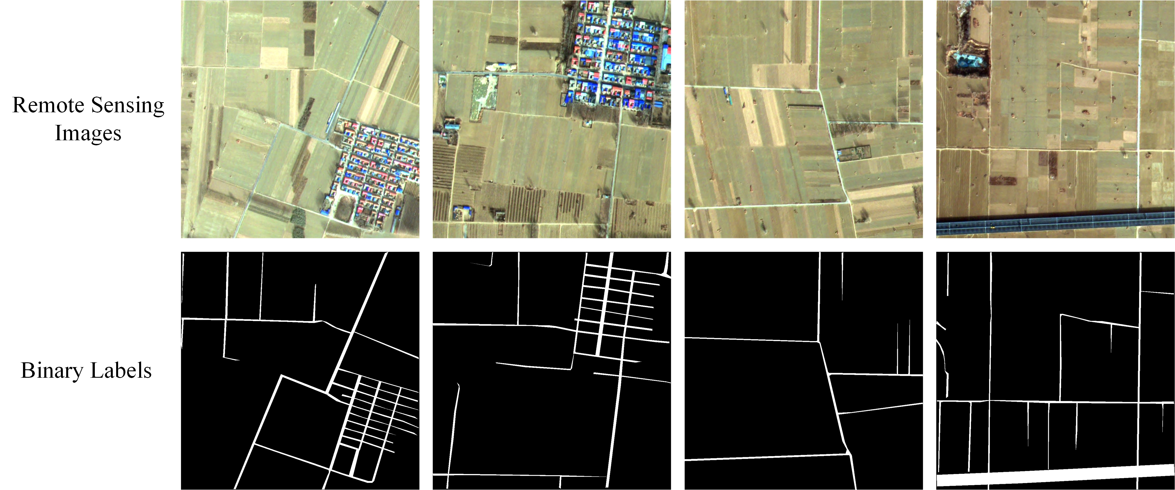

**Figure A2.** Partial Training Samples of XARoads Dataset

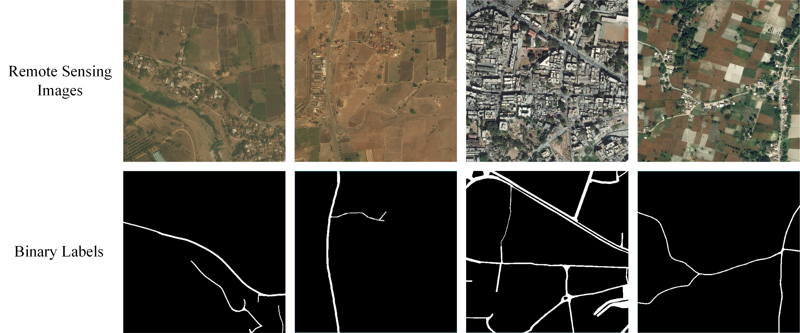

**Figure A3.** Partial Training Samples of DeepGlobe Dataset

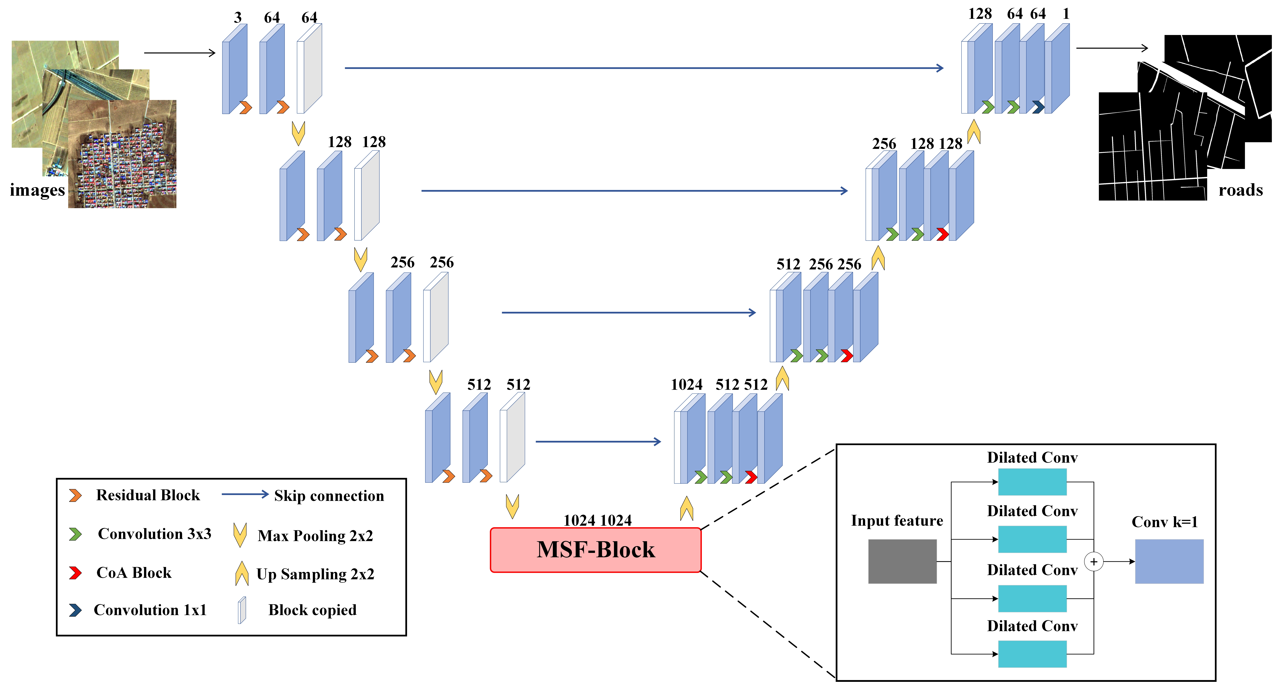

**Figure A4.** RC-MSFNet Network Model Structure

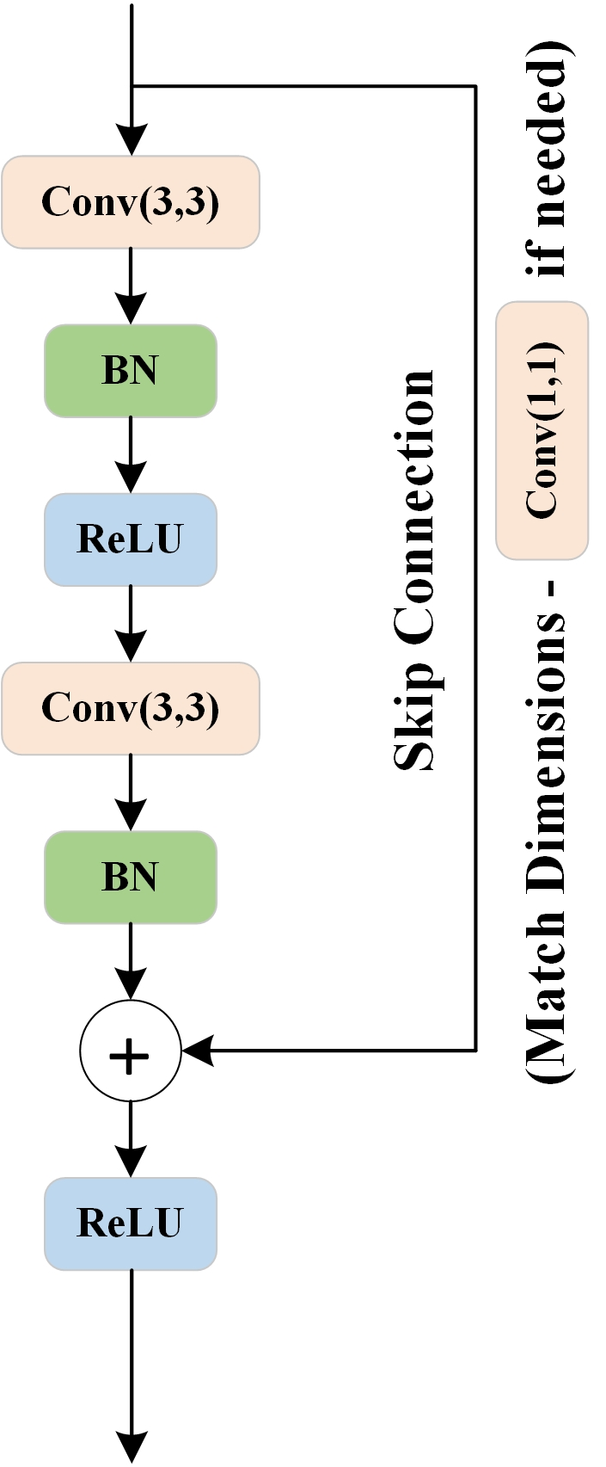

**Figure A5.** Residual Neural Network Structure Diagram

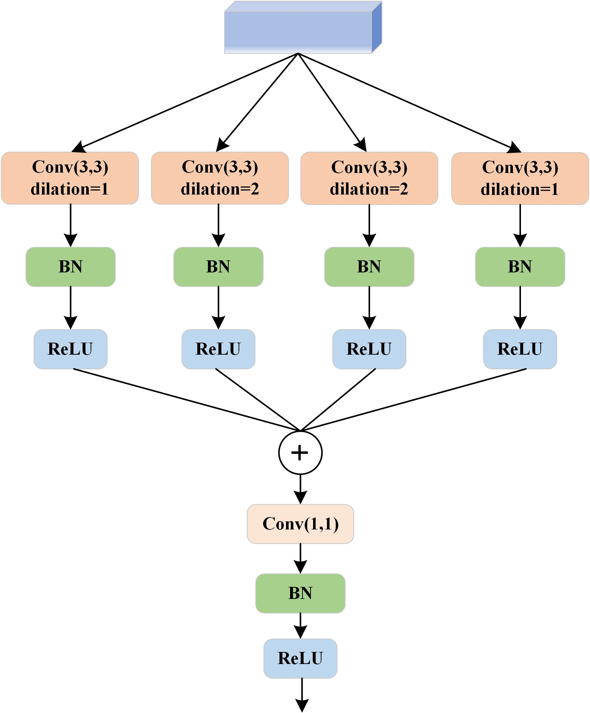

**Figure A6.** Multi-scale Fusion Atrous Convolution Module

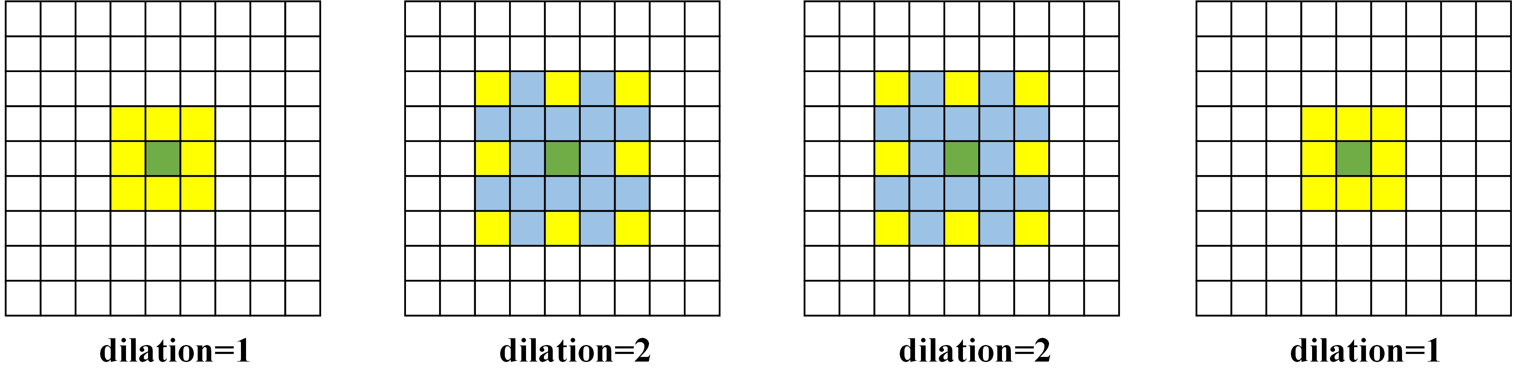

**Figure A7.** Different Levels of Atrous Convolution

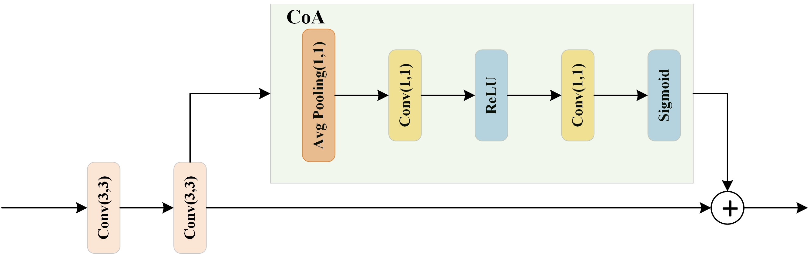

**Figure A8.** Framework Diagram of a CoA Module

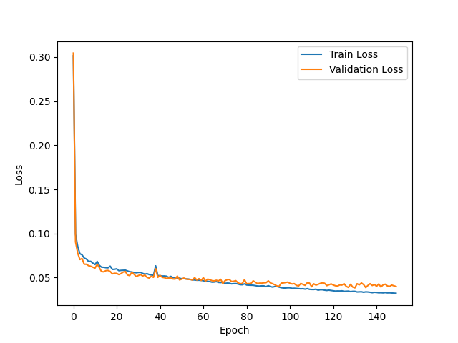

**Figure A9.** Training and Validation Loss During Model Training

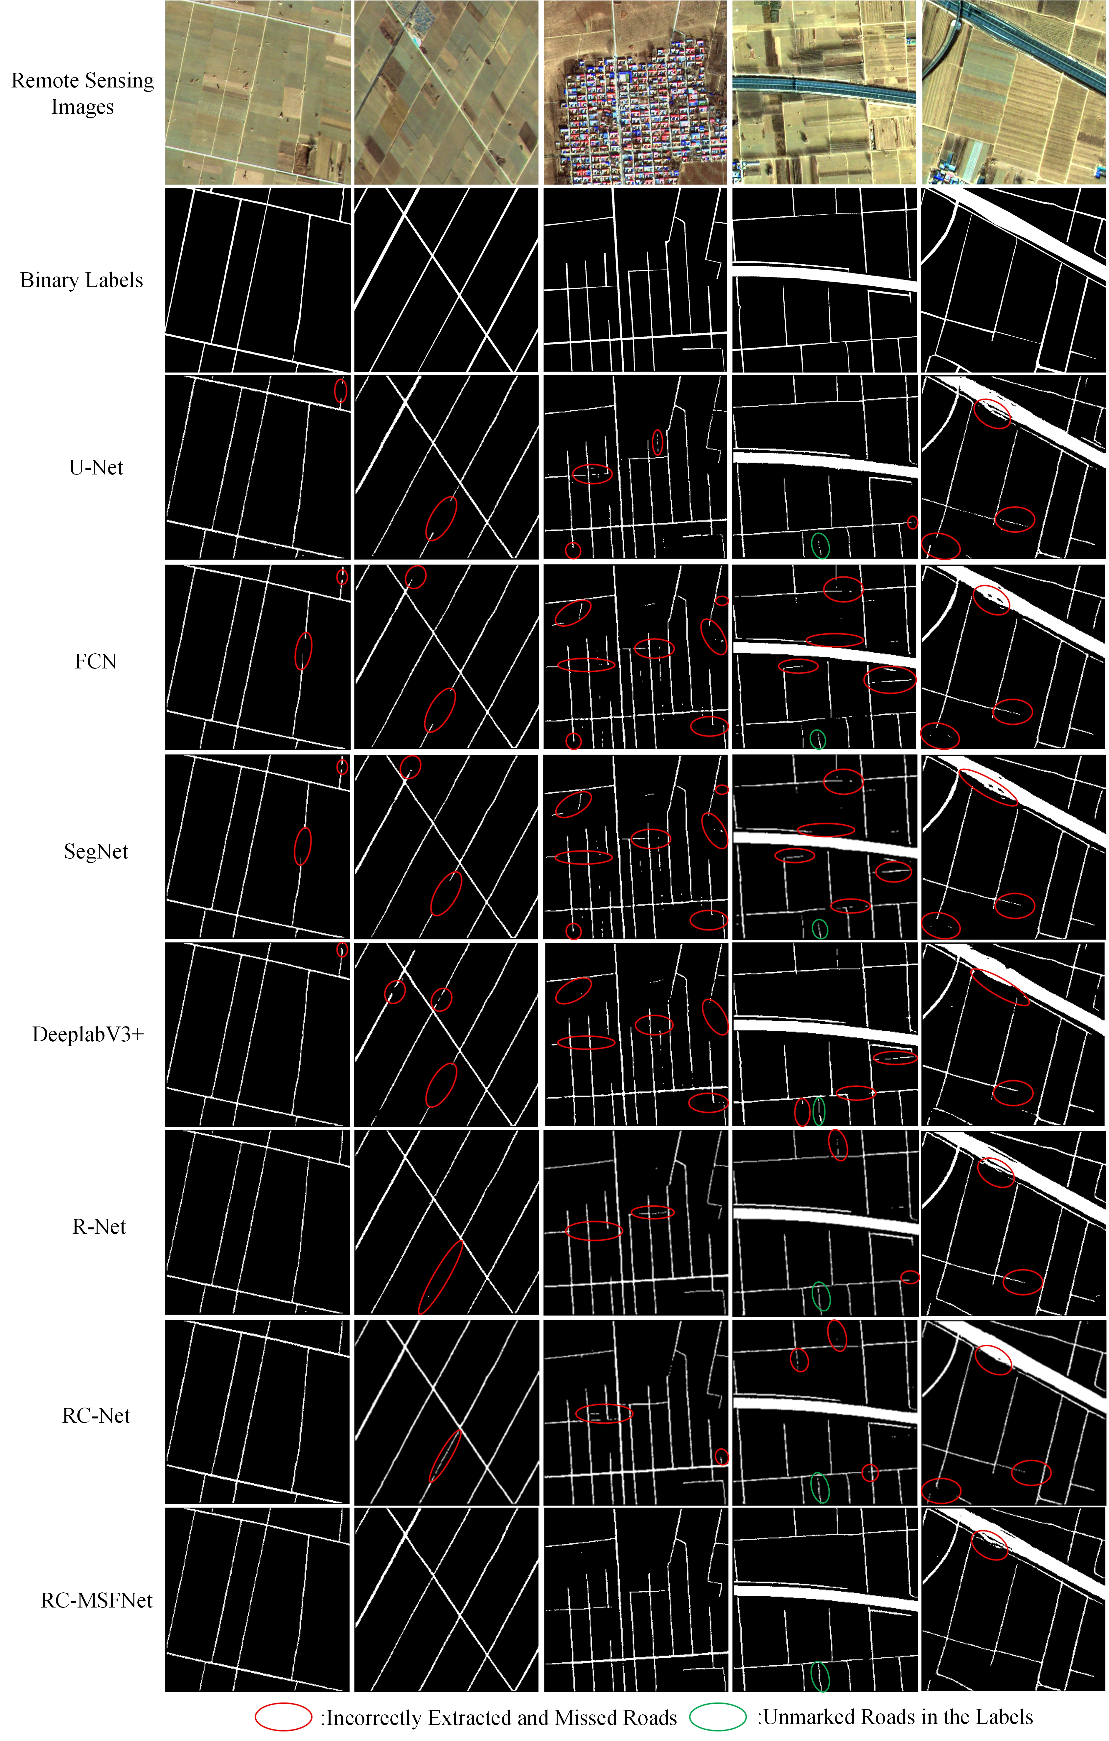

**Figure A10.** Extraction Results of Rural Roads Using Different Models on the XARoads Dataset

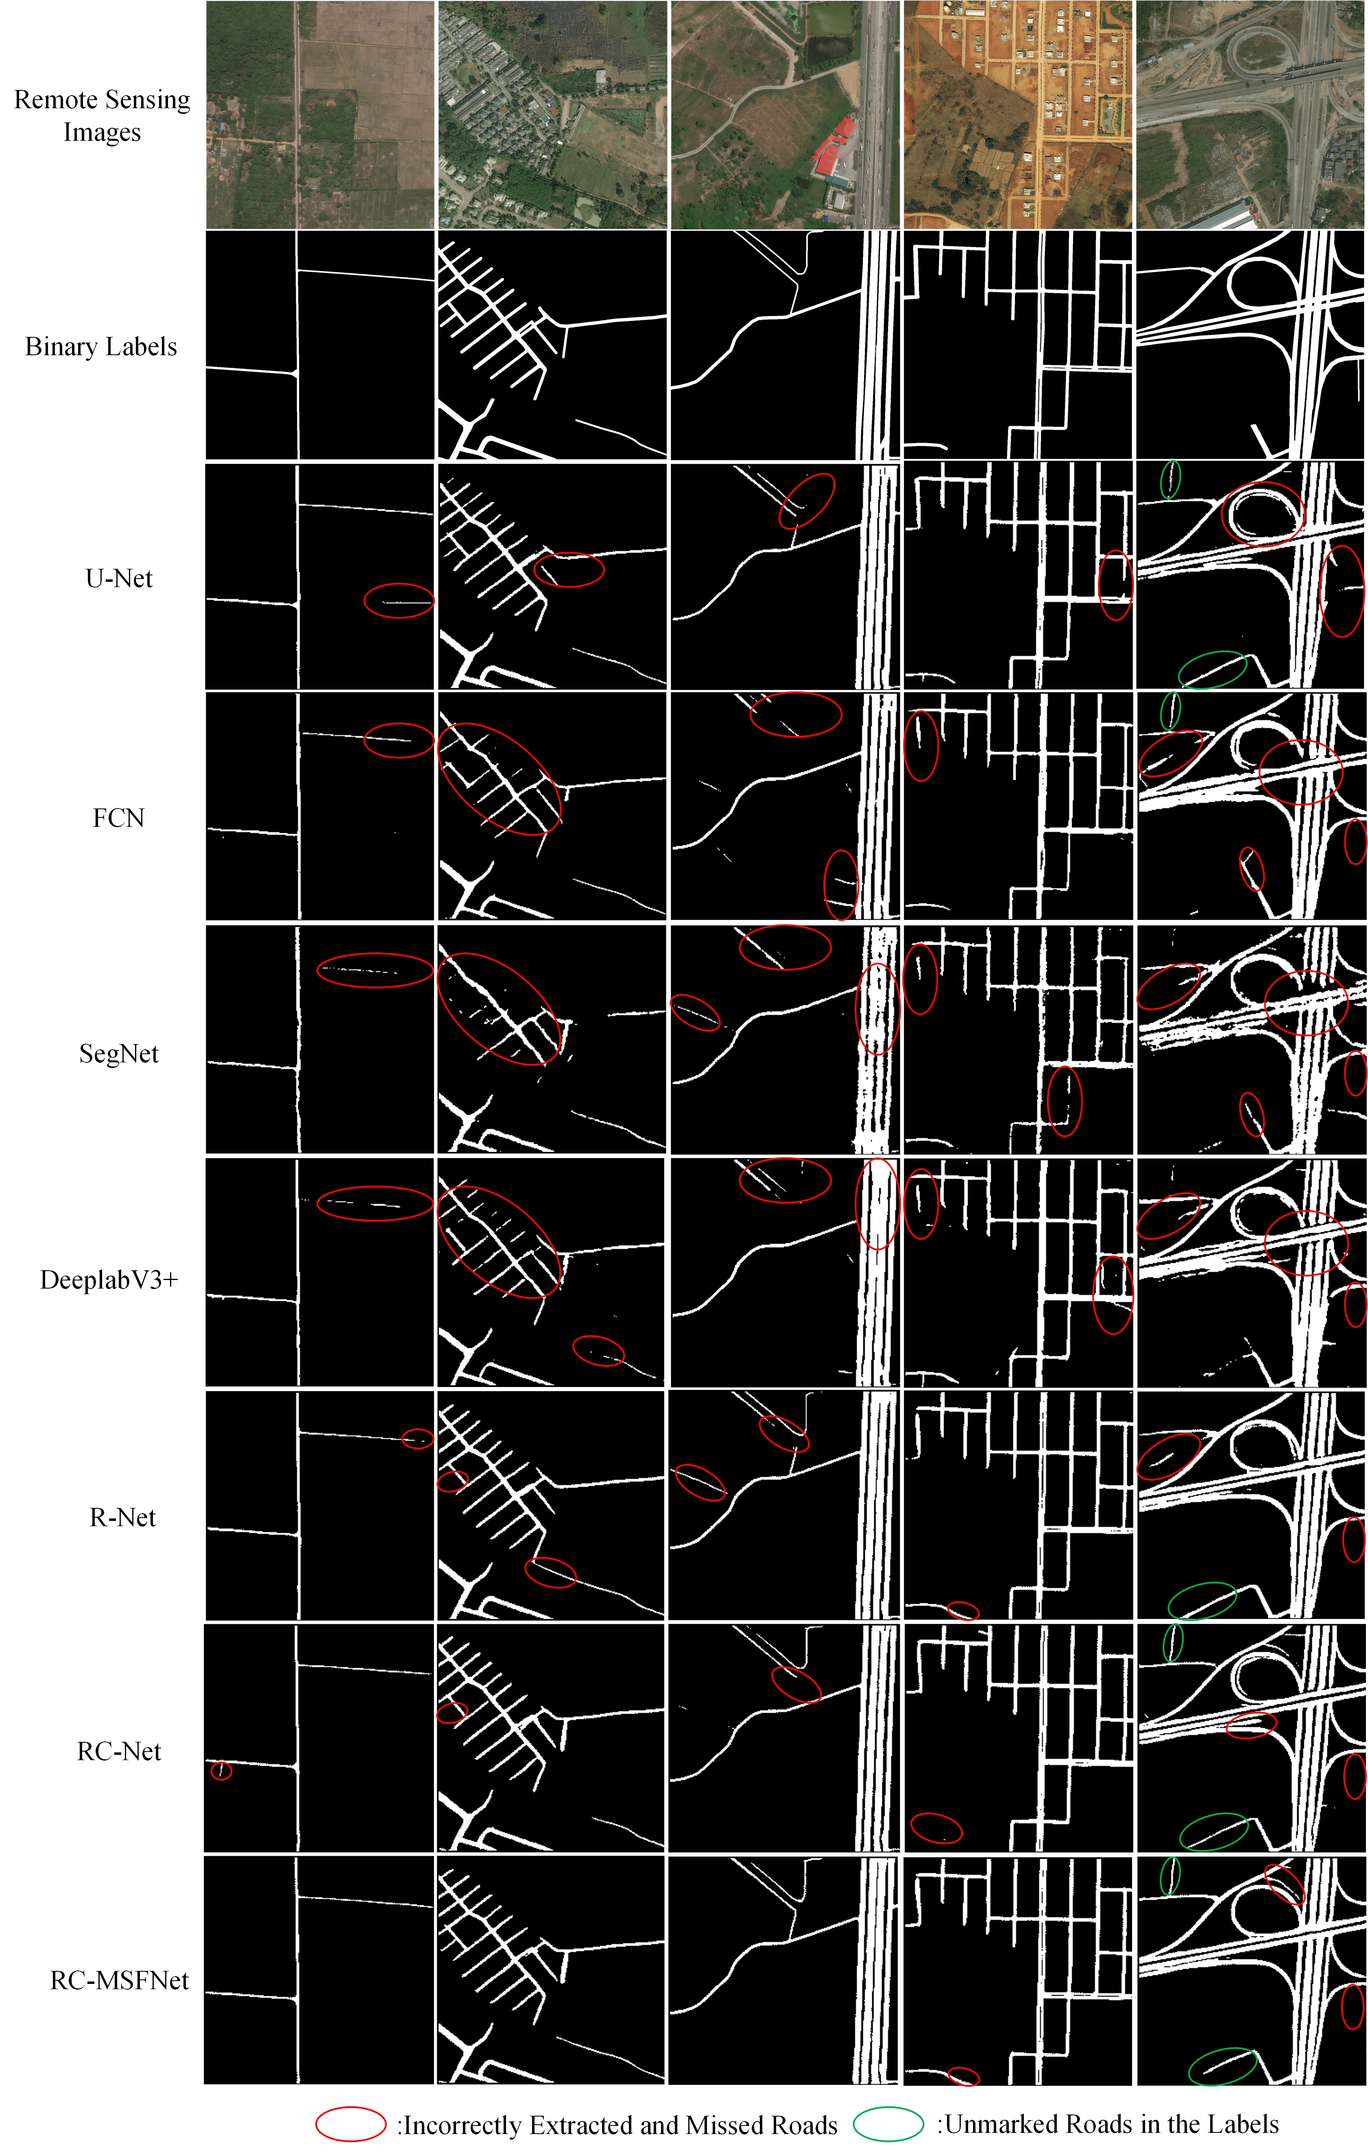

**Figure A11.** Extraction Results of Rural Roads Using Different Models on the DeepGlobe Dataset